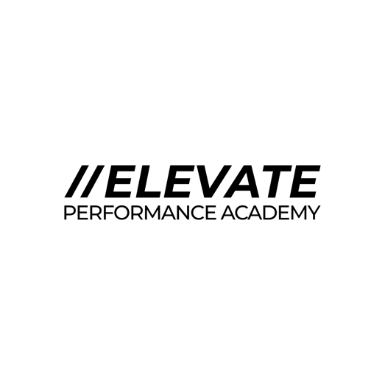
Accessibility and Inclusiveness Policy
At Elevate Performance Academy Ltd, we are committed to fostering an environment that promotes accessibility, inclusiveness, and equity for all individuals, regardless of their abilities, backgrounds, or identities. We believe in creating a workplace and learning environment where everyone feels valued, respected, and empowered to contribute their best.
Principles:
- Equal Opportunity: We provide equal opportunities for employment, advancement, and participation in our programs without discrimination based on disability, race, ethnicity, gender, age, sexual orientation, or any other characteristic protected by law.
- Accessibility: We strive to ensure that our facilities, services, and digital platforms are accessible to all individuals, including those with disabilities. This includes physical accessibility of buildings, accommodations for visual and auditory impairments, and usability of our online resources.
- Inclusive Culture: We promote a culture of inclusiveness where diversity is celebrated and differences are respected. We encourage open communication, collaboration, and understanding among all members of our community.
- Accommodation: We are committed to providing reasonable accommodations to enable individuals with disabilities to perform their jobs effectively and participate fully in our programs. We engage in an interactive process with employees and participants to determine appropriate accommodations based on individual needs.
- Training and Awareness: We provide training and resources to our staff and stakeholders to increase awareness of accessibility issues, foster sensitivity, and ensure compliance with accessibility standards and laws.
- Continuous Improvement: We regularly review and update our policies, practices, and facilities to enhance accessibility and inclusiveness. We welcome feedback from our community to identify areas for improvement and address concerns promptly.

Implementation:
- Accessibility Committee: We have established a dedicated committee responsible for overseeing accessibility initiatives, ensuring compliance with regulations, and promoting best practices across all aspects of our operations.
- Accessibility Standards: We adhere to relevant accessibility standards and guidelines, such as the Americans with Disabilities Act (ADA) and Web Content Accessibility Guidelines (WCAG), in developing and maintaining our physical spaces and digital platforms.
- Community Engagement: We actively engage with our community, including individuals with disabilities, to understand their needs and preferences, and involve them in decision-making processes related to accessibility.
Accountability:
All employees, contractors, and stakeholders are accountable for upholding this policy and contributing to a culture of accessibility and inclusiveness at Elevate Performance Academy. Violations of this policy will be addressed promptly and may result in disciplinary action.
Conclusion:
By embracing accessibility and inclusiveness as core values, Elevate Performance Academy strives to create an environment where everyone can thrive and contribute to our shared success. Together, we can achieve our mission of empowering individuals to reach their full potential in a supportive and inclusive community.

Date signed – January 2025
Name of signee – Chad Thorne
Signature -

